

Dr. Elizabeth, Pennington inc.
2020-12-09
Dr. Pennington
Unit 8121 Box 7987, DPO AE 53132
Phone: 5128114429
Fax: 4876180570

Re: Sara, Warren
PHN: 751353599
Birthdate: 13-Jan-1981
Address: 58913 Harvey Fort Apt. 334, Lake Caseystad, IA 31138
Patient number: 1169055916

To Whom It May Concern:

This is a medical letter to state the above patient is pregnant with expected delivery date of 11-Oct-2025. Hoping this information is satisfactory for your requirements.

Thank you.

Sincerely,
Dr. Elizabeth, Pennington
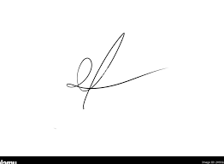
FRCS© NCMP
Clinical Assistant Professor, UBC
Department of Obstetrics and Gynecology SMH

